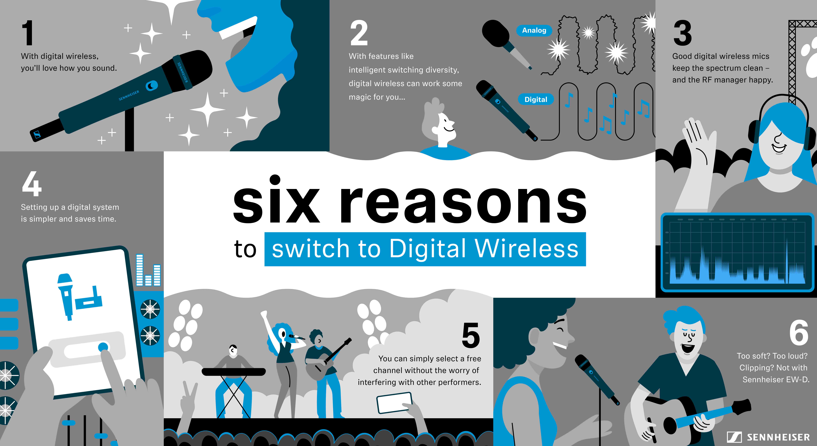Six reasons why you should switch your wireless microphone from analogue to digital

Of course, audible sound is analogue, but that doesn’t mean you and your audience should have to forego the many benefits of digital wireless microphones. In some environments, it may even be crucial to finally make the switch from analogue to digital. Here are the top six reasons for making the change.

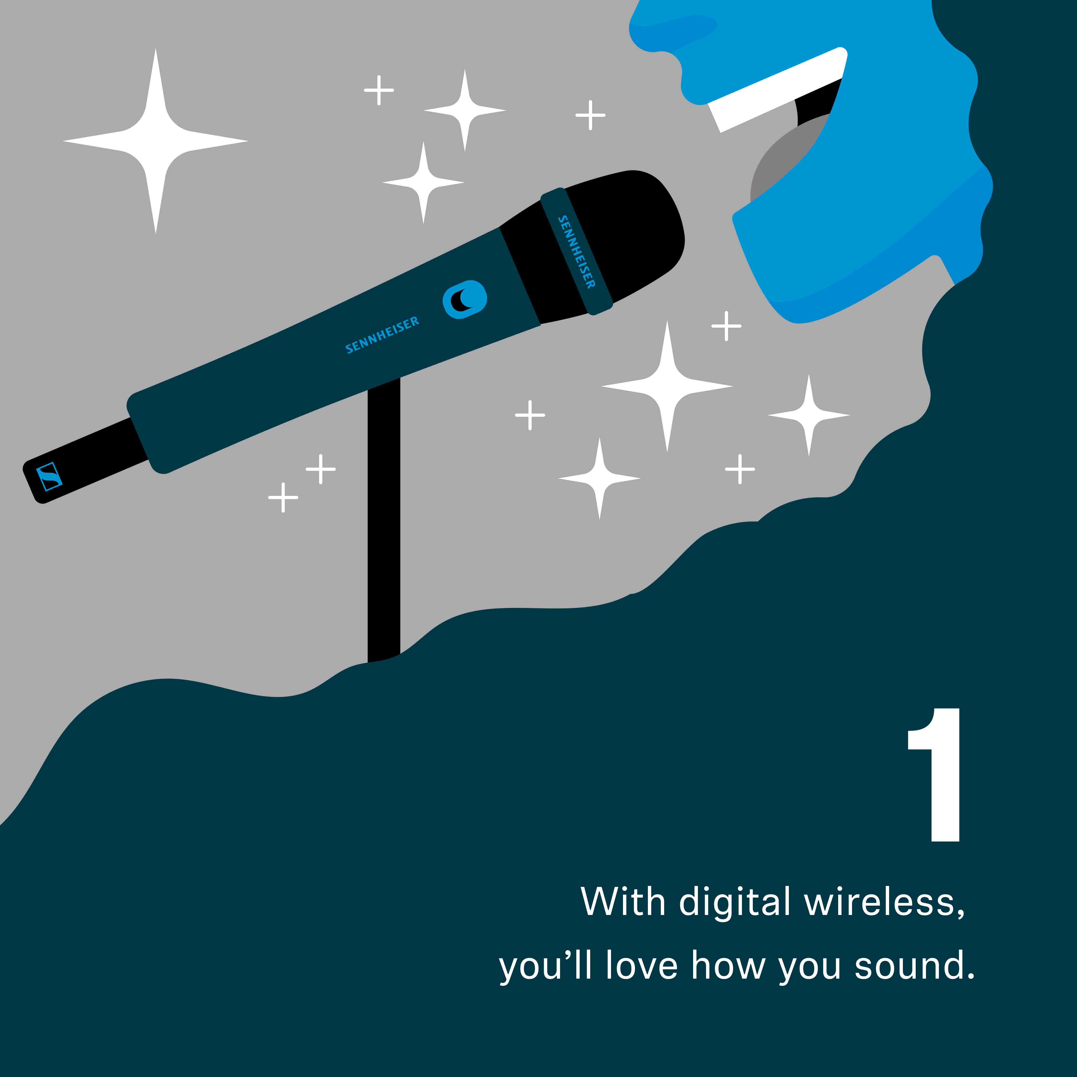
(1) The audio will sound better and cleaner.
As you may have heard, digital systems do not require a compander (a combined compressor/expander). In analogue wireless microphones, a compander compresses the audio signal, lifting it above the noise floor of the RF transmission, and expands it again in the receiver to recreate the original audio signal. Unfortunately, this noise reduction is not a noiseless process in itself, and you may hear your compander pumping, breathing or hissing. A compander-less digital system will not only massively improve the audio quality for your audience, but will also help you to hear your performance more clearly through your monitoring system.

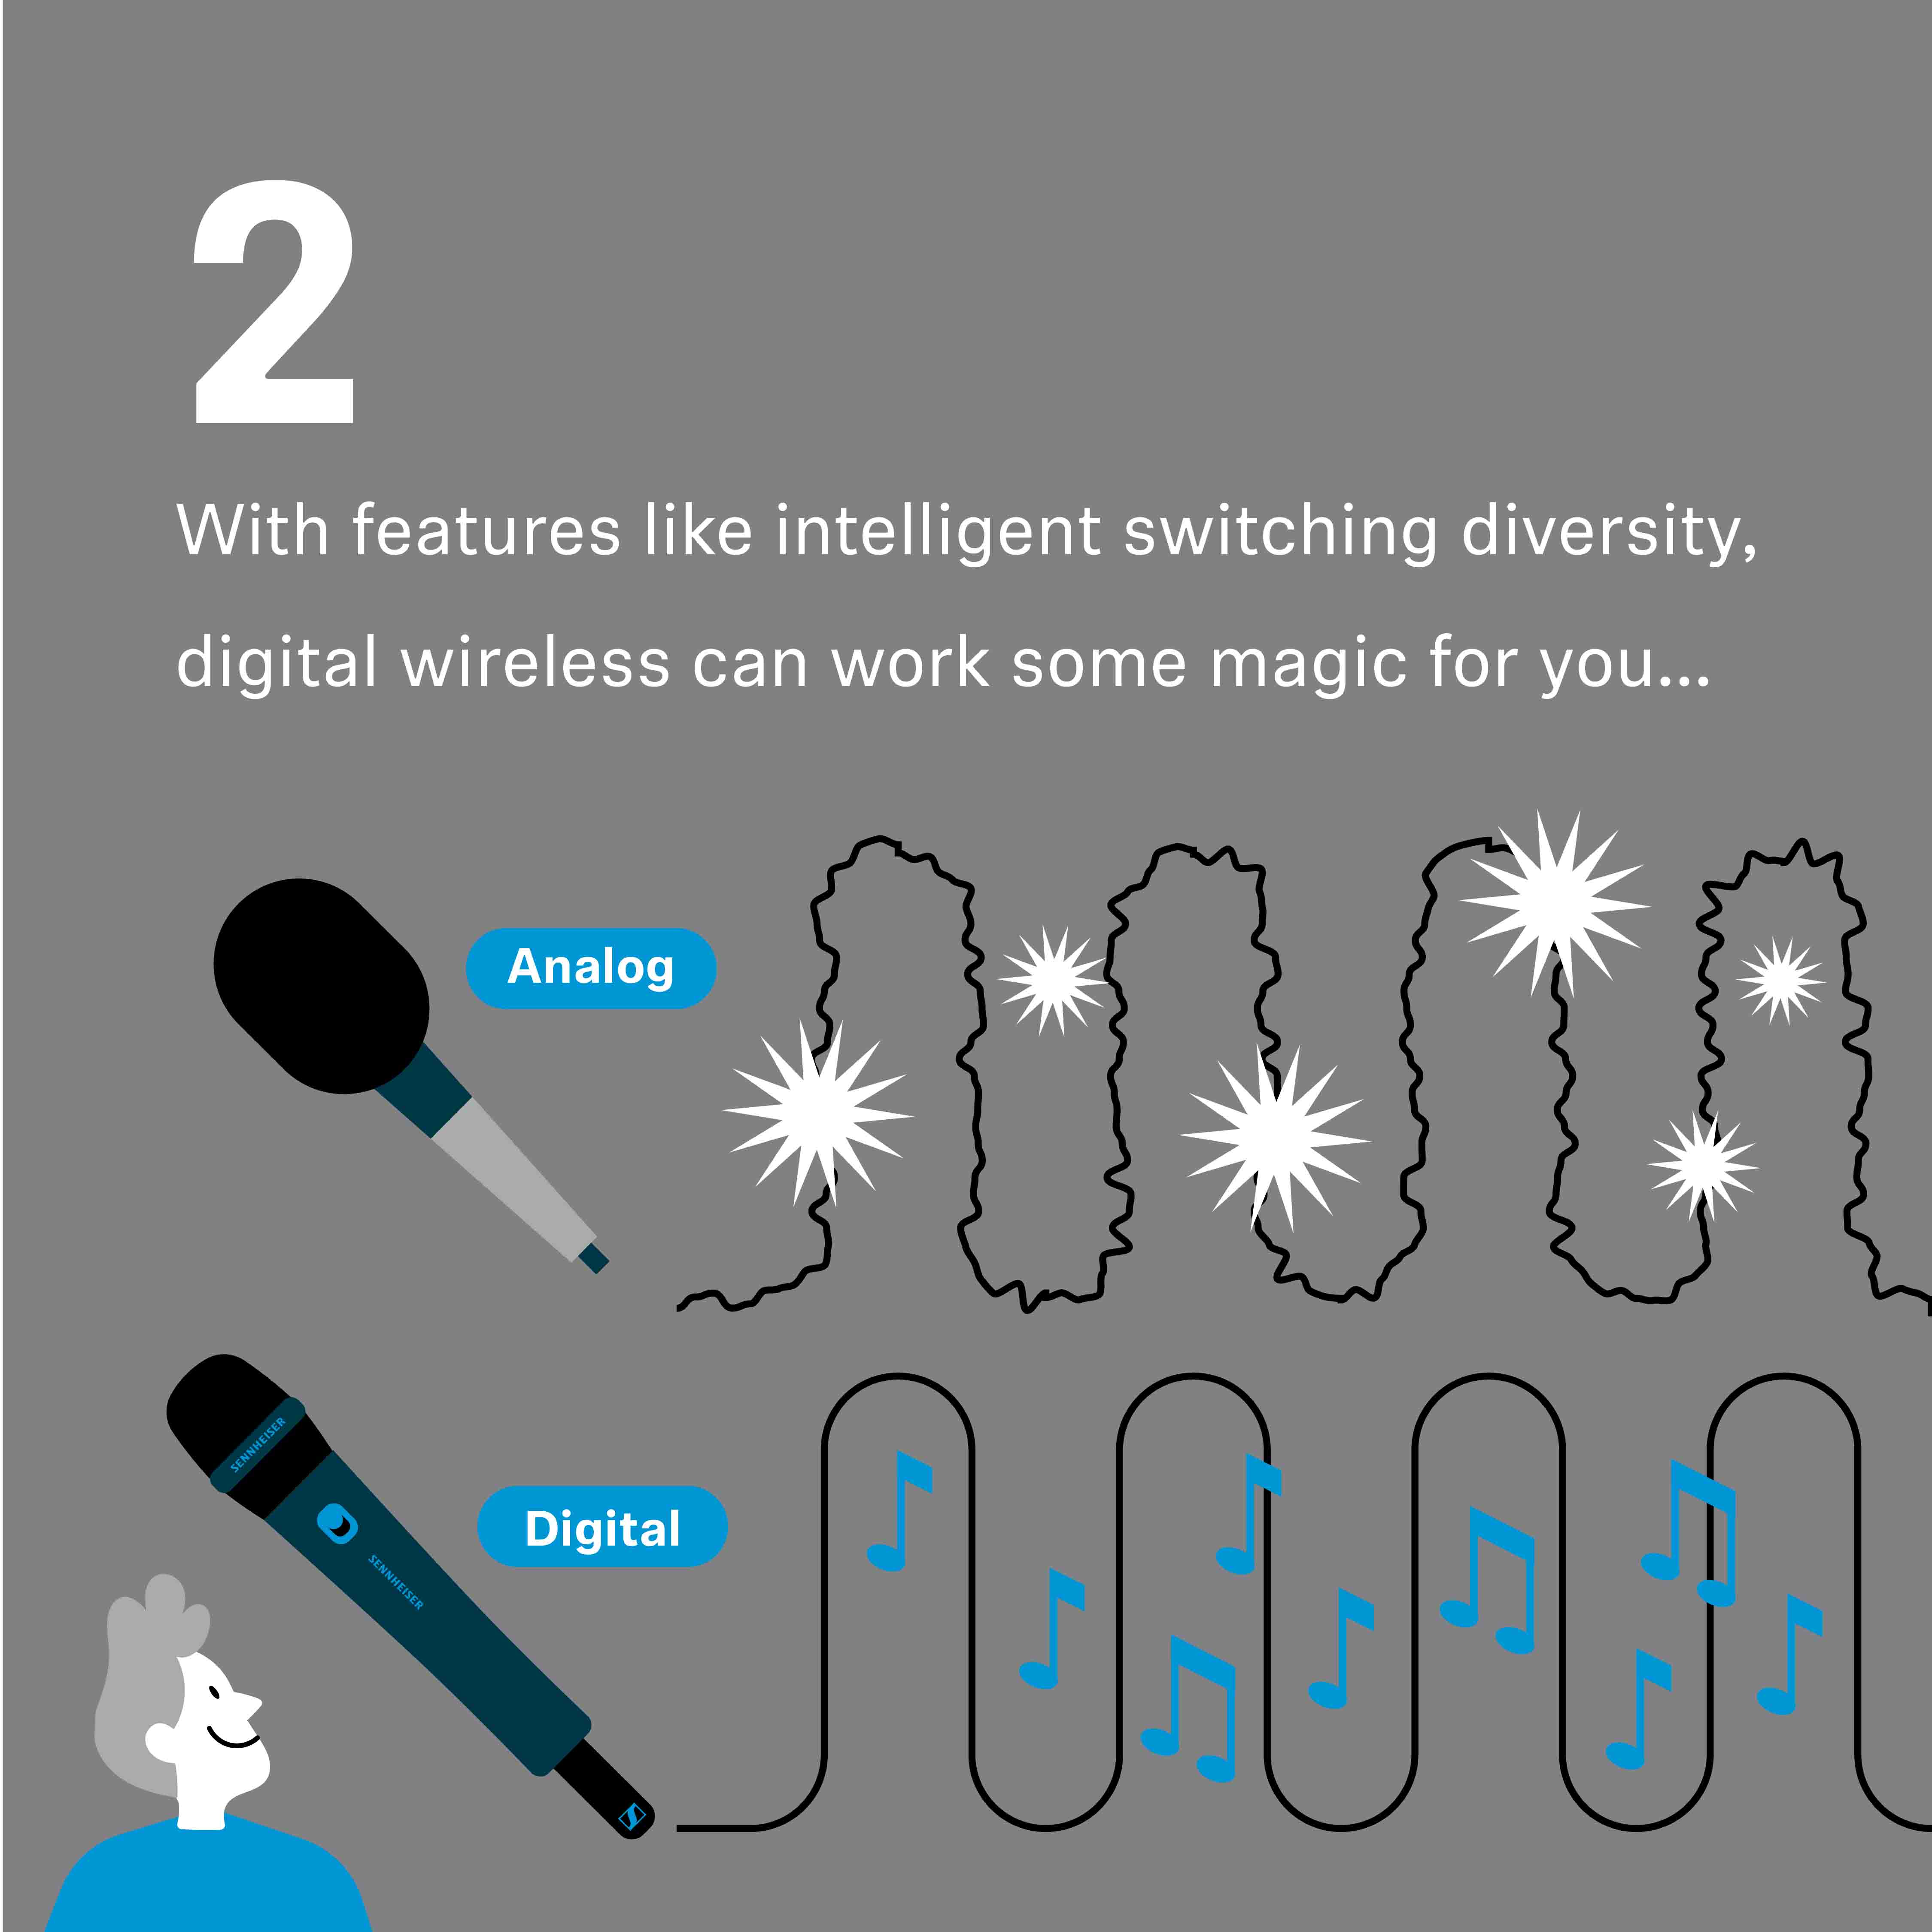
(2) With features like intelligent switching diversity, digital wireless can work some magic for you.
A phenomenon called “fading” is the natural enemy of any wireless microphone transmission. This means that the microphone signal can be strong in one spot, but then extremely weak in another, where reflected signals cancel out the direct signal between the wireless microphone and its receiver. When you’re really pushing your boundaries, a good digital microphone system like Sennheiser’s Evolution Wireless Digital can work some magic to help you stay “on air”: intelligent switching diversity, an RF channel equalizer, error correction and even error concealment will keep your signal intact and your confidence high.

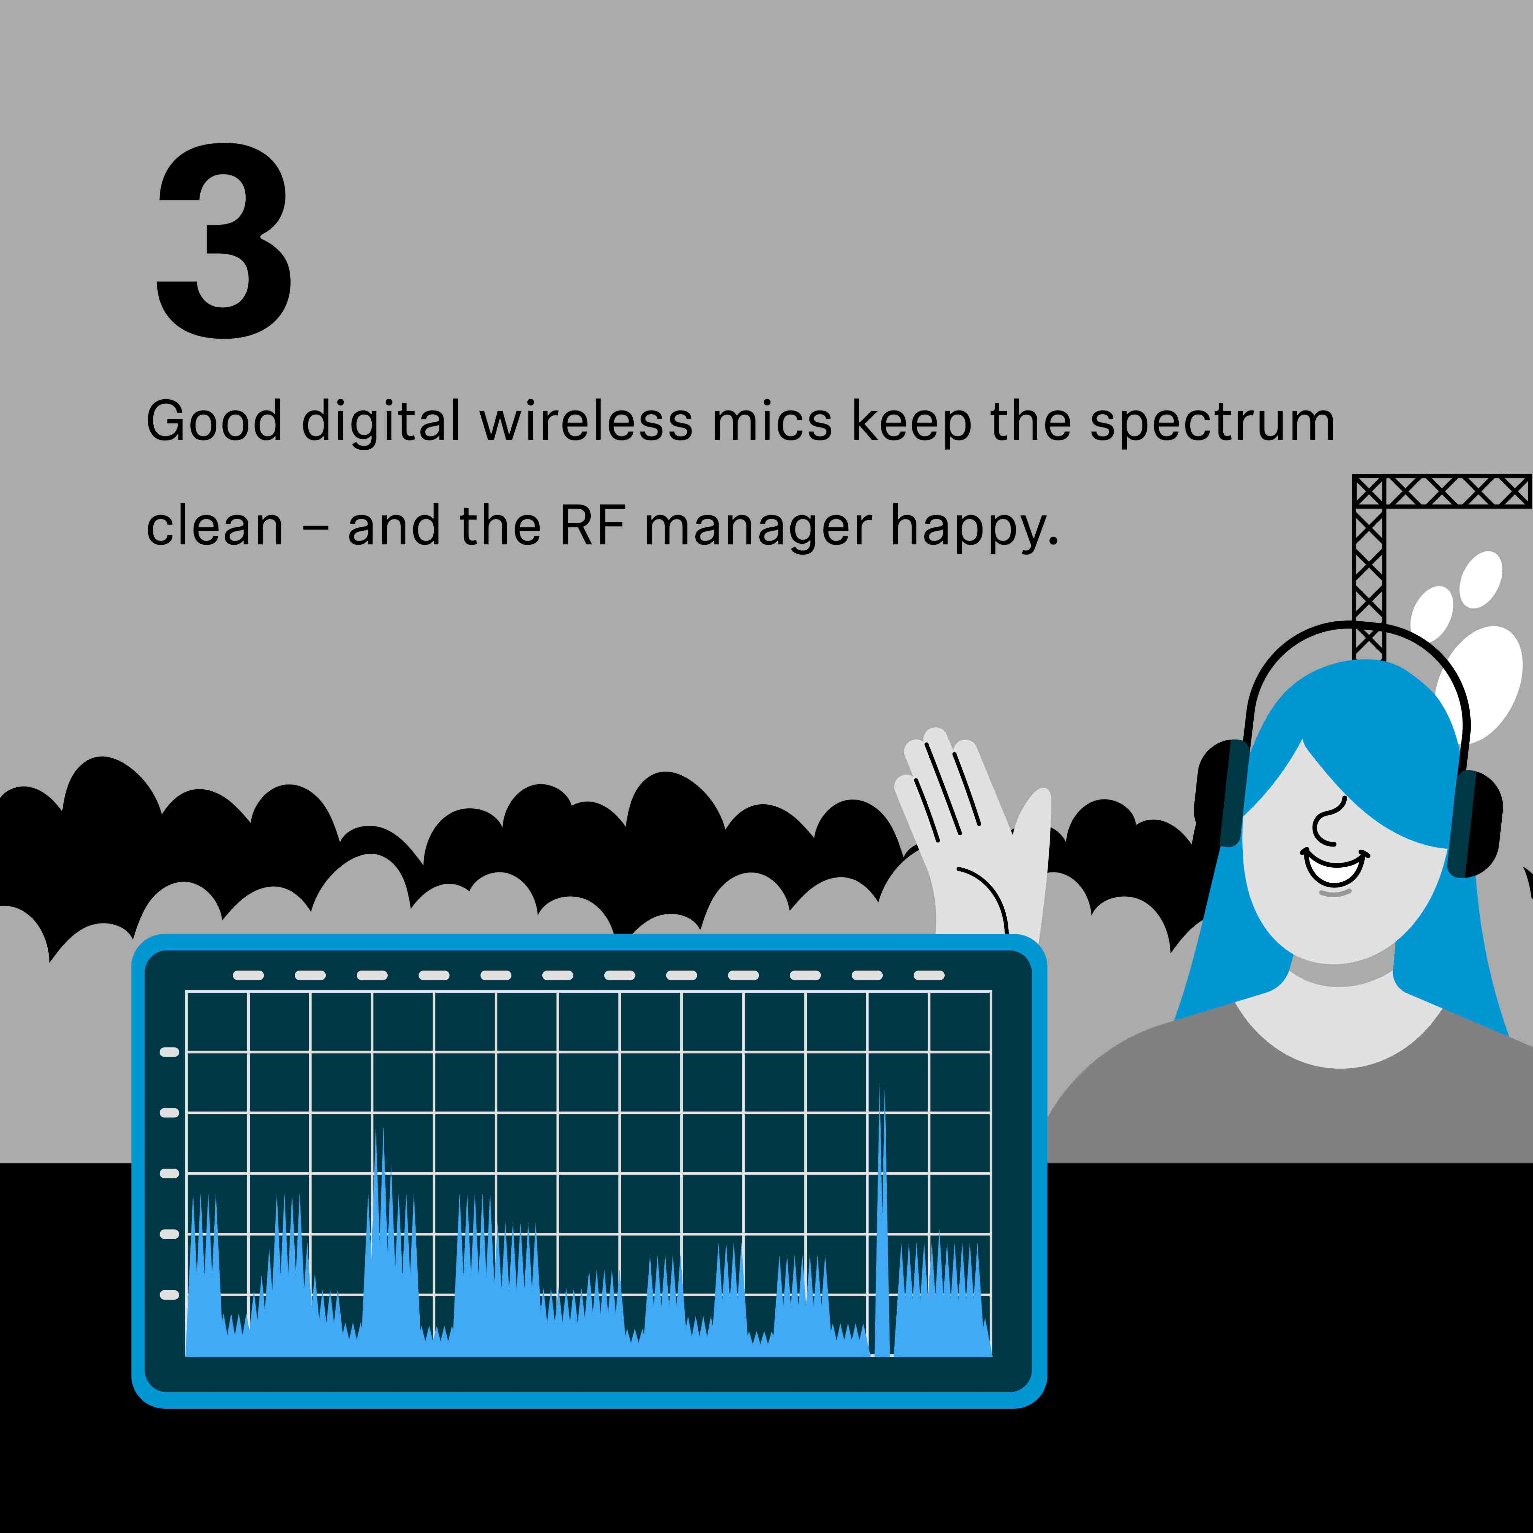
(3) The frequency manager at a festival will welcome your digital gear with open arms.
The wireless spectrum is a shared and a shrinking resource and very densely populated – not just by microphones but by many other production tools, too. At a festival or venue, the frequency manager is responsible for handling all frequency matters. When you show up with an analogue microphone system, it’ll add to the frequency manager’s workload, because they need to calculate “intermodulation products”. These are basically useless emissions that occur when multiple wireless microphones are used on stage. Did you know that 32 channels of analogue wireless can create 16,000 possible intermodulation products or noise sources? When, for example, available frequencies at a larger event are really scarce, the frequency manager may not be able to fit your analogue equipment in, and your energetic stage show might find itself tied down by a cabled microphone.

A good digital wireless microphone like Sennheiser’s Evolution Wireless Digital, however, makes the job of the frequency manager easier. It will emit its carrier frequency only – and no disturbing intermodulation products that occupy additional spectrum. Transmission frequencies can simply be placed next to each other at regular intervals, whereas with analogue wireless, the frequency manager must work around all the intermodulation frequencies that the microphones produce. Therefore, digital wireless frees up spectrum for additional audio links or other wireless production equipment – and this space is just what the frequency manager needs most.

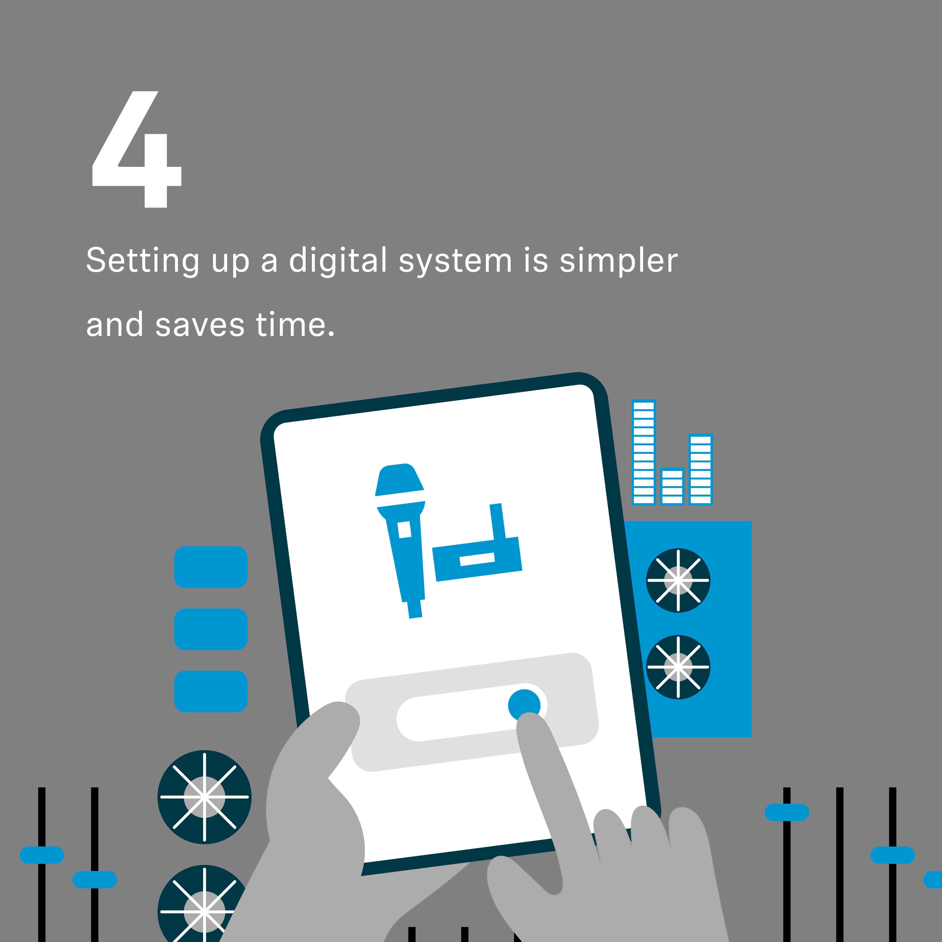
(4) Setting up a digital system is as easy as using an app.
If you double up as the sound engineer of your band, you’ll know it can be painful to get the audio going. With digital systems like Sennheiser’s Evolution Wireless Digital, an intuitive app guides you through a few easy steps and you’re ready to gig in a snap – on professional TV-UHF frequencies. But beware: Your band members’ awe of your seemingly magical abilities may diminish ever so slightly if you show them how easy this actually is…

(5) You can simply select a free channel without the worry of interfering with other performers.
“But if a frequency is free, why should I worry about disturbing other bands’ gear?” some may ask. The reason for worrying is called intermodulation products. Very simply put: If there is more than a single analogue wireless microphone on stage, the wireless microphones will emit several RF frequencies – not just the ones that you selected for transmitting your audio. The same happens if a wireless microphone gets too close to a receiver – like an in-ear monitoring pack, for example.

These additional and essentially useless frequencies are called intermodulation products. They can interfere with other wireless microphones, or in-ears for that matter, and they eat up spectrum space. With analogue microphones, and unfortunately also many digital microphones, you will always have the issue of intermodulation products.

However, some advanced digital systems like the Sennheiser Evolution Wireless Digital don’t emit intermodulation products. This makes it very simply when it comes to your band’s next gig: You or the venue technician can simply select a free channel and you don’t need to worry about anything. No intermodulation products, no interference – and you have saved valuable spectrum space, too.

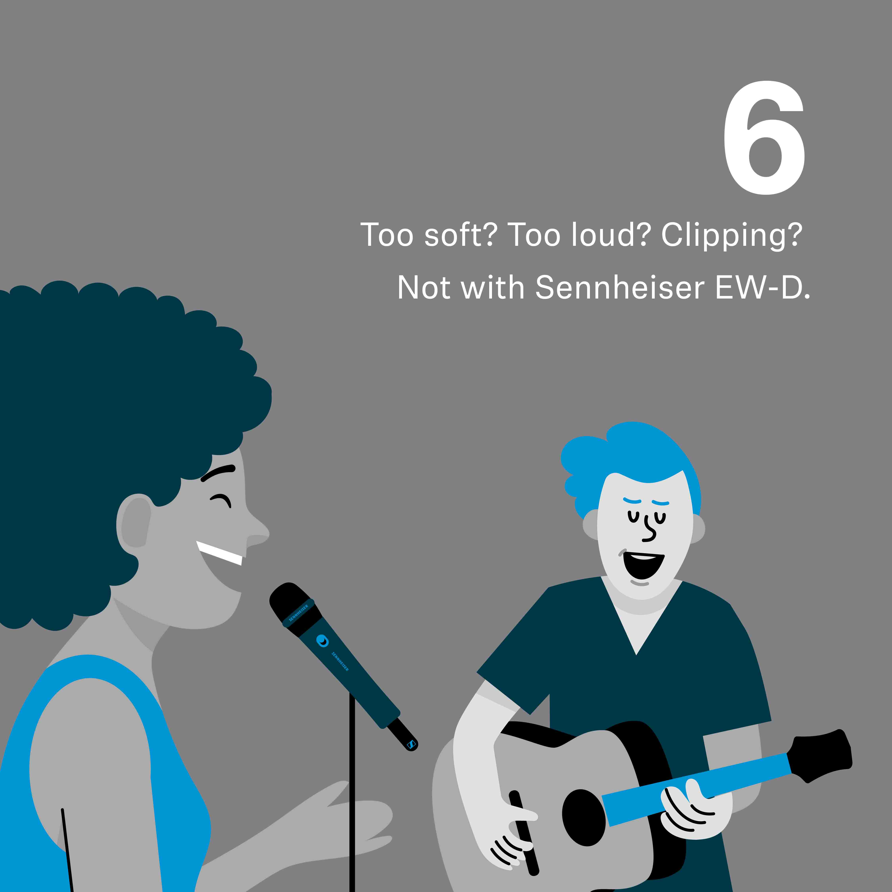
(6) Too soft, too loud, clipping? Not with Sennheiser’s Evolution Wireless Digital.
Gain is probably one of the most underestimated issues you may face when setting up a wireless microphone. In setting the gain, you determine how sensitive your mic is. If you scream into the mic and the gain is too high, you will sound horrible and the audio will clip. If you have a soft voice and the gain is too low, nobody will hear you amidst your powerful backline… The good news is that Sennheiser’s Evolution Wireless Digital has an input dynamic range of a full 134 dB, even surpassing the dynamic range of most microphone capsules, so you can pick up everything from a soft whisper to a plane engine without having to adjust the transmitter gain.

Making the switch to a good digital wireless microphone can help improve your performance in many ways. Opt for a microphone system that works on reliable UHF frequencies if you want to take your music to the stage. If you like, you can learn more about Evolution Wireless Digital here and the Smart Assist app here.

You can also visit our website for an interactive version of the six reasons why.

(Ends)

The high-resolution jpg and png graphics accompanying this media release can be downloaded here.

The graphics in this media release were created by the lovely people at Cartoonbase.

About the Sennheiser brand
We live and breathe audio. We are driven by the passion to create audio solutions that make a difference. Building the future of audio and bringing remarkable sound experiences to our customers – this is what the Sennheiser brand has represented for more than 75 years. While professional audio solutions such as microphones, meeting solutions, streaming technologies and monitoring systems are part of the business of Sennheiser electronic GmbH & Co. KG, the business with consumer devices such as headphones, soundbars and speech-enhanced hearables is operated by Sonova Holding AG under the license of Sennheiser.

www.sennheiser.com
www.sennheiser-hearing.com

Global Pro Audio Press Contact
Stephanie Schmidt
stephanie.schmidt@sennheiser.com
+49 (5130) 600 – 1275

